

ECE 2564: Project 1

Project Completed by Illa Rochez



June 22, 2021

Virginia Tech

GitHub ID: Illar47

# Report Summary:

The purpose of this report is to outline the goals of the Project 1 assignment for ECE 2564. In addition, the document will outline the design implemented in the solution to this problem, as well as any additional bonus features that were implemented.

# Project Description:

General concept:

The main concept of this game is that it follows the adventures of an “explorer” that is represented by a user specified graphic. The graphic can move about to gain experience. They can only move while they have energy. Upon reaching a predetermined threshold, the “explorer” levels up. Leveling up zeros the experience. Moving decreases an “explorer’s” energy. One unit of energy can be used for multiple moves. Energy can be replenished by feeding the “explorer”. All features noted in the given project assignment can be completed by this program.

Summary of stats:

The following stats are displayed on the screen and are updated throughout gameplay

|  |  |
| --- | --- |
| ***Stat*** | ***Description*** |
| Level | Explorer’s level |
| Energy | Explorer’s energy |
| Experience | Explorer’s experience (in this current level) |
| To Next | Required experience to pass the current level  (this number only changes when the level increases) |
| Move | The number of moves the explorer has made (this number resets every time the energy level decreases) |

Player controls:

The following inputs and their corresponding command are displayed below

|  |  |
| --- | --- |
| ***Input*** | ***Command Operation*** |
| w | Move Up |
| a | Move Left |
| s | Move Down |
| d | Move Right |
| f | Feed |

Example states:

Shown below are some example states. Each is labeled with a small description outlining what state it represents.

Exp: 00 Energy: 1

Level: 00 To Next: 01

Shown to the left is the basic start state of the explorer game. The explorer generates in the center of a 3 x 3 grid. All of the values are in their zero states.

|  |  |  |
| --- | --- | --- |
|  |  |  |
|  |  |  |
|  |  |  |

Move: 0

Exp: 00 Energy: 1

Level: 01 To Next: 03

Shown to the left is the state of the game screen after the user moves the explorer DOWN one space after starting the game. The explorer is shifted down one spot, and the Move value increases by one. Additionally, the explorer levels up to level one, and the To Next value increases to three

|  |  |  |
| --- | --- | --- |
|  |  |  |
|  |  |  |
|  |  |  |

Move: 1

Exp: 00 Energy: 2

Level: 00 To Next: 01

Shown to the left is the state of the game screen after the user uses the FEED command. Explorer does not move; however, the energy is increased by 1.

|  |  |  |
| --- | --- | --- |
|  |  |  |
|  |  |  |
|  |  |  |

Move: 0

Updating the Baud Rate:

Additionally, the BLED (Boosterpack RGB_LED) changes color according to the current UART speed. Shown in the table below are the pairings utilized.

|  |  |
| --- | --- |
| ***Baud Rate*** | ***Boosterpack RGB LED Color*** |
| BAUD_9600 | Red |
| BAUD_19200 | Green |
| BAUD_38400 | Blue |
| BAUD_57600 | White |

Different displays:

There are three main displays within the game. The Title (splash) screen, the game play screen, and the game over screen.

The title screen contains the project name and the creator’s name. When the explorer dies, the game over screen is displayed. This screen displays “GAME OVER” and the highest level achieved during gameplay.

The gameplay screen displays the player’s level, energy, current moves, experience, and the needed experience to reach the next level. It also displays the gameplay area and the “explorer”. The explorer can not leave the gameplay area, but it can move to nine different positions in the space.

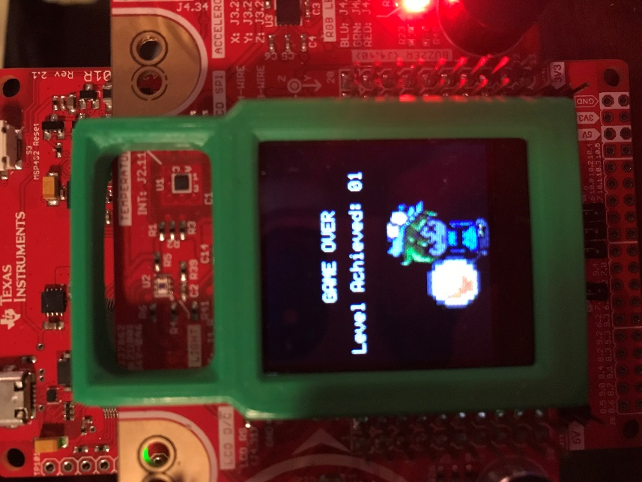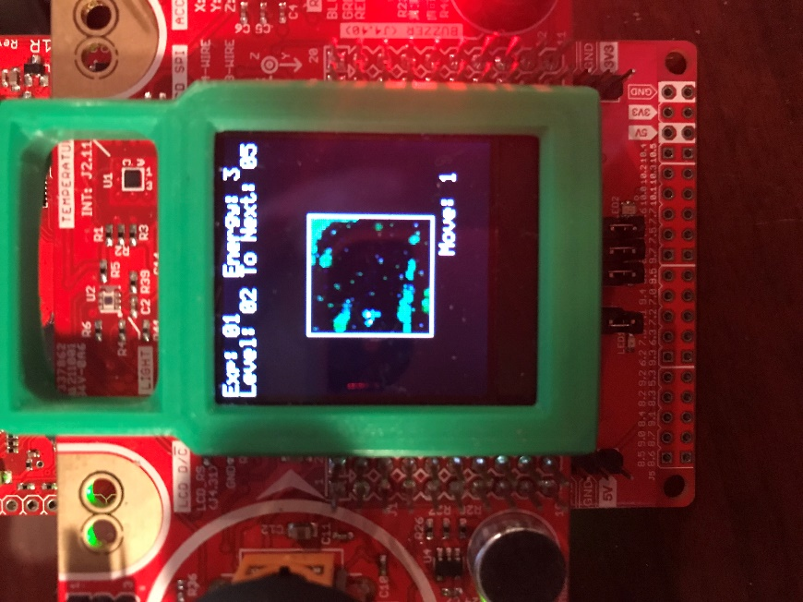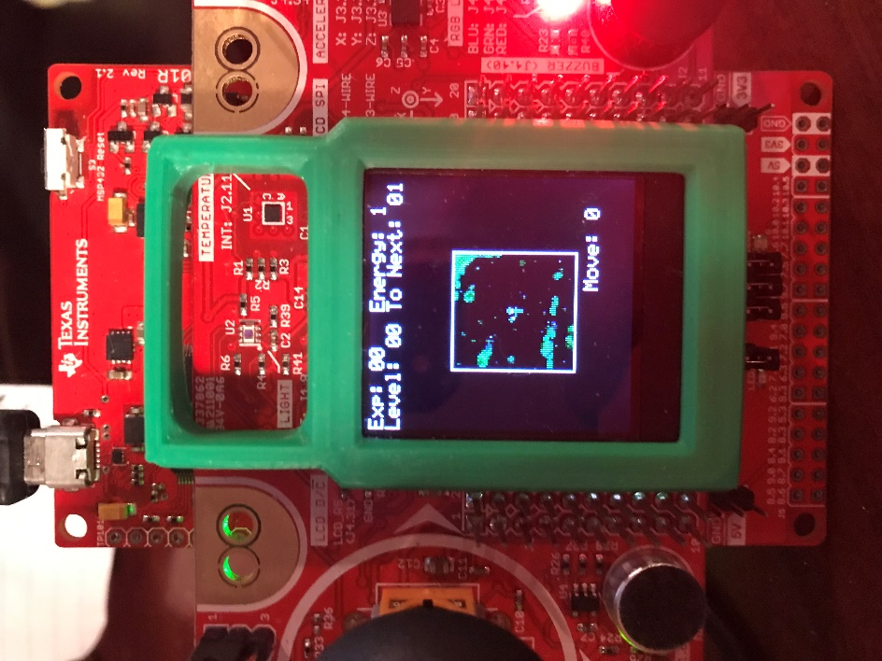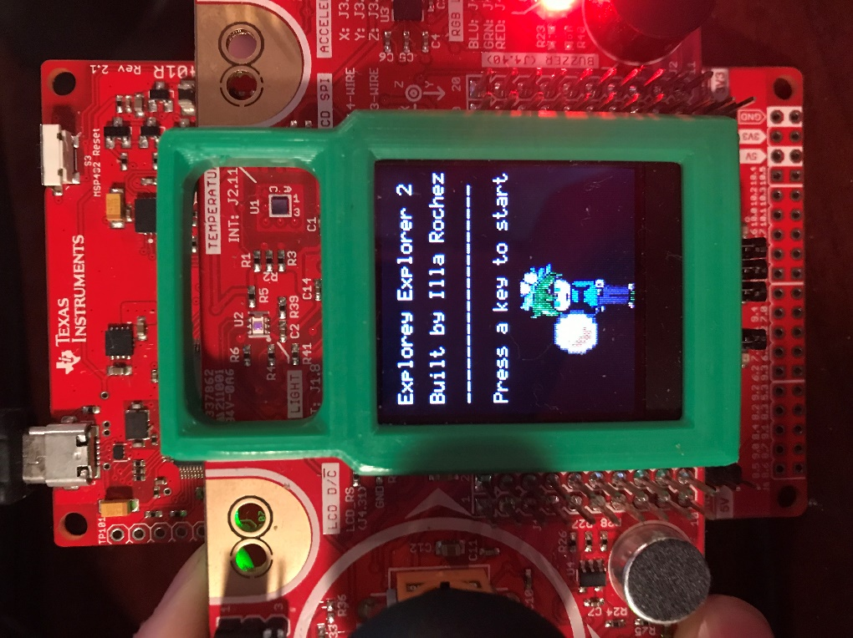

This is the GAME OVER screen

This is an example state during gameplay (explorer is at position MidLeft)

AThis is an example state at the start of gameplay (explorer is at postion MidMid)

This is the start (splash) screen

Game Progression:

In order to move, the “explorer” must have at least one energy present. Energy is bound between the inclusive values [0-5]. If the energy falls below 0, the “explorer” dies and the game over screen. Energy cannot exceed 5. For every 2 moves, one energy is deducted. The move parameter on the screen reflects the number of moves since the last deduction.



The explorer cannot move beyond the gameplay space. Sending the explorer, a command to move beyond the gameplay space does not decrement the Energy, increment the experience or level, and it leaves the “explorer” in its current position.

# Main FSM:

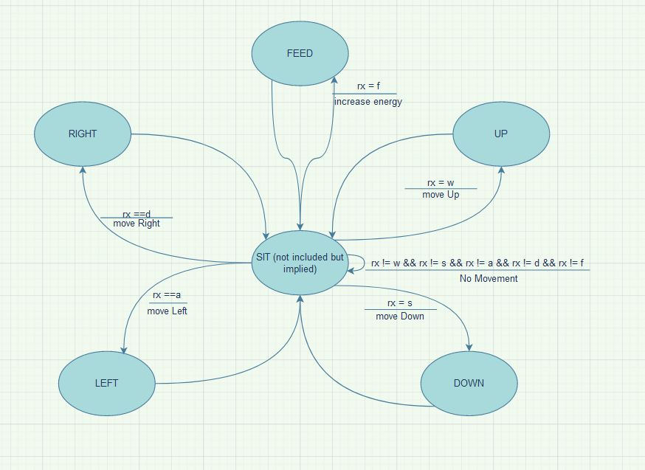The main finite state machine focuses on the movement of the explorer. There is a neutral state SIT that is not a part of the machine but serves as a resting point. When no keystroke is entered into the machine, or an invalid keystroke is typed, this is the state that the machine is in. If a valid keystroke is typed and the explorer is able to, the explorer will shift into one of the following states: FEED, UP, RIGHT, LEFT, DOWN. The FEED state can be entered as long as energy is less than 6. When the user types an “f”, the feed state is entered. This state increases the energy of the explorer. If the energy is maxed out, then the energy will not increase further. The remaining states are all related to movement. Theses states have a more complicated underlying state machine that is dependent upon the explorer’s placement in the gameplay area. In general, if there are no walls and the explorer has energy, when the correlating keystroke is entered by the user, the explorer will move in that direction. After the action is completed, the explorer re-enters the SIT state.

# Bonus:

The bonus features that were implemented were the custom explorer Icon and the custom Title and GAMEOVER screen. The Image Reformer was used to create custom graphics to represent the explorer.

The initial character was designed as seen below:



The change that was to be reflected was as the explorer leveled up (specifically at level 5 and level 7) the explorer would gain more gear. It was difficult to showcase detailed differences, so instead the small icon would progressively gain a larger magnifying glass. A custom gameplay space was also implemented with bushes and foliage for the explorer to traverse through. These images can be seen below:

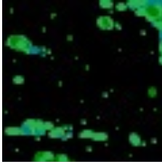

*Level 1 explorer*

*Level 5 explorer*

*Level 7 explorer*

Gameplay area background

The art that was initially designed to be the explorer character was then modified to make the custom title and game over screen. The healthy explorer is displayed along with the title, and on the game over screen, a “dead” explorer is shown. These displays are shown below along with the art used:



The Start Menu

The Start Menu Art

The Game Over menu

The Game Over menu Art

Table of Implemented Features:

|  |  |
| --- | --- |
| *Implemented Feature* | *Expected Points* |
| Custom Explorer | 75/75 |
| Custom Title and Game-Over Screen | 25/25 |
|  | **Total: 100 expected Bonus Points** |